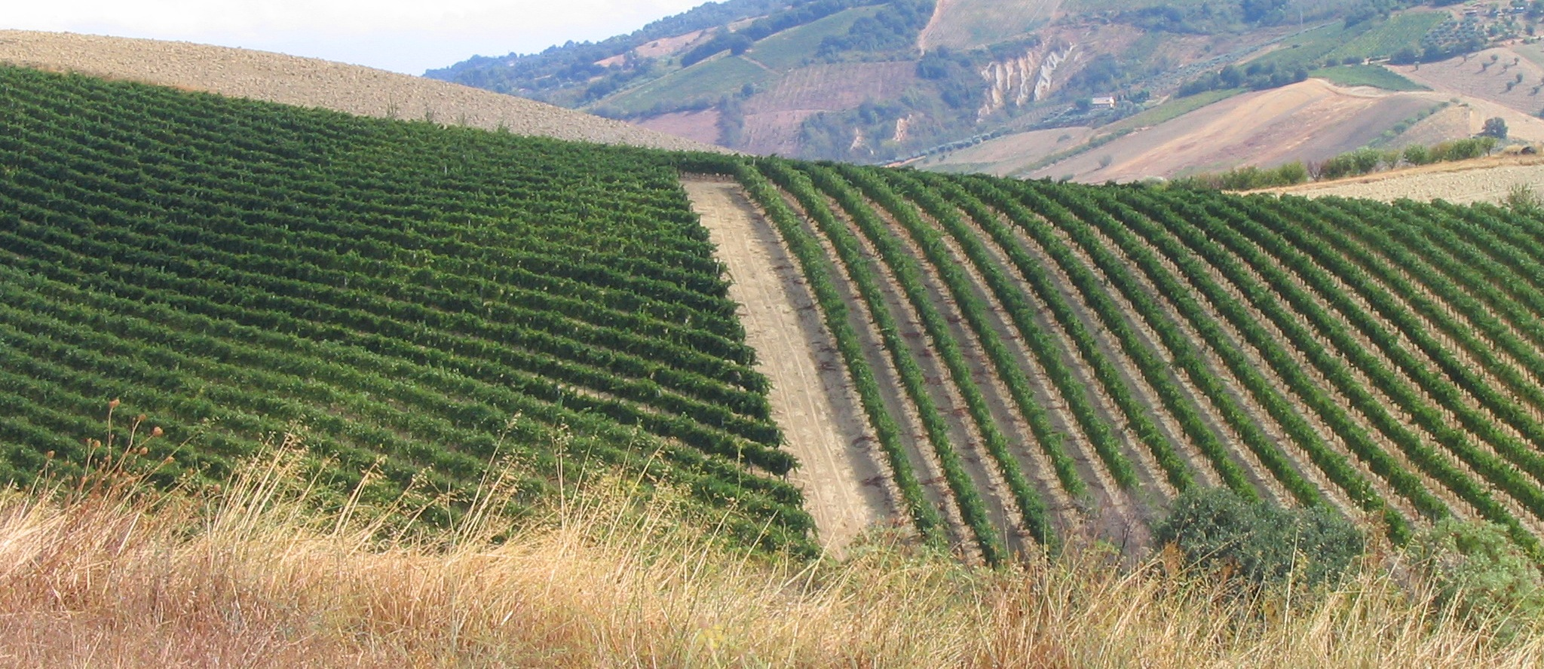

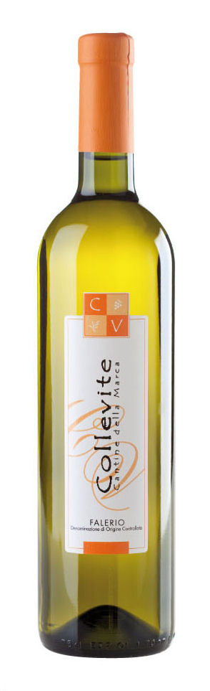

Collevite CV

FALERIO
Denominazione di Origine Controllata

Zone of production: “Piceno” territory Grape varieties: Passerina, Trebbiano e Pecorino.
Middle production: 80ql of grapes.
ALTITUDE: 250 – 300 m. above sea level.
Harvest period: end of September
Vinification: in absence of skins ,temperature checked
CHARACTERISTICS
Colour : delicate straw-yellow
Bouquet : this whine is perfumed with odors of acacia
Taste: dry, savory ,harmonic, to long persistence ,thanks
to the consistent sour whipand the great mineralità.
SERVING SUGGESTIONS: excellent if combined with
molluscs and dishes of fish

ALCOHOL CONTENT – 12.50 % vol.
SERVING TEMPERATURE – 6° C.

SIZES – Bottles from 75 cl.
WRAPPING – Cardboards from bottles, in vertical position.

Collevite – Via Valle Cecchina 9, Monsampolo del Tronto, Ascoli Piceno, Italia – tel 0735 767050, fax. 0735 767052 - info@collevite.com – www.collevite.com

Falerio

